1. Configuration of Network Devices using Packet Tracer tools (Hub, Switch, Ethernet, Broadcast)

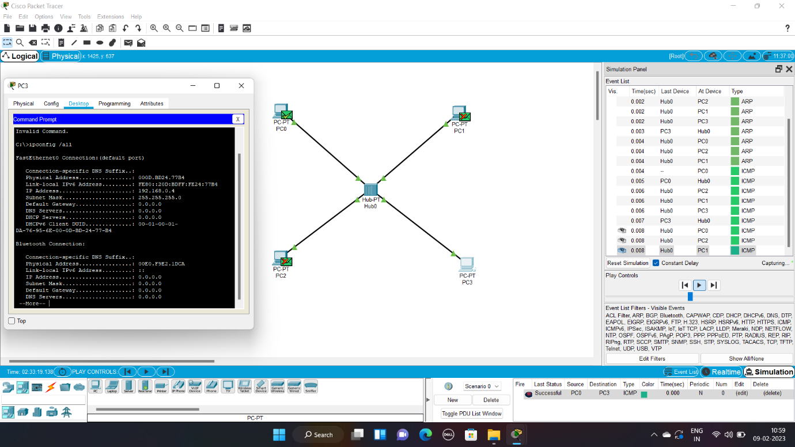

2. Design and Configuration of Star Topologies using Packet Tracer

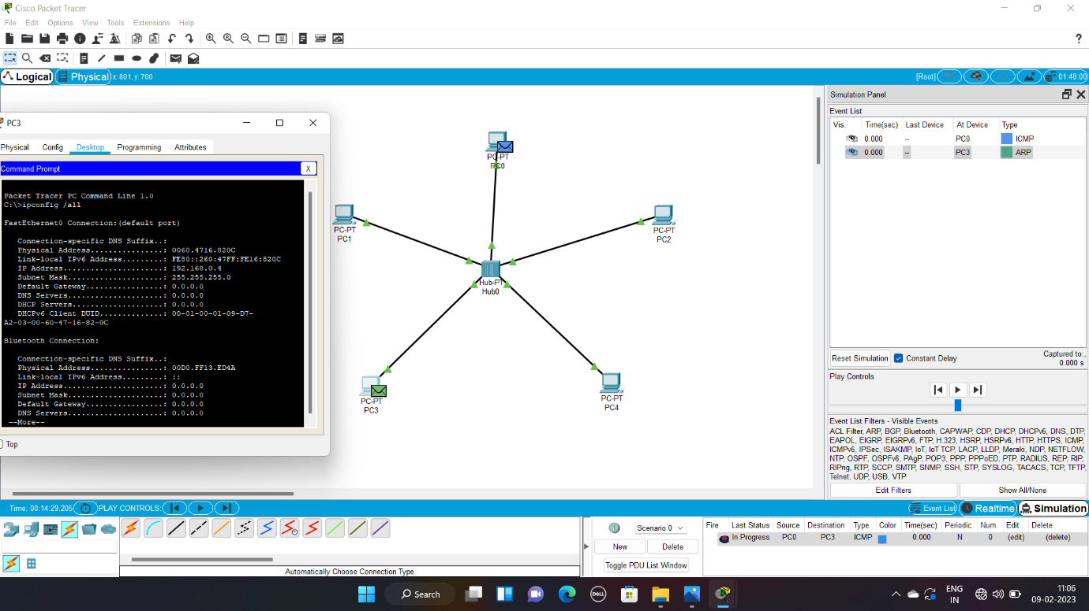

3. Design and Configuration of BUS Topologies using Packet Tracer

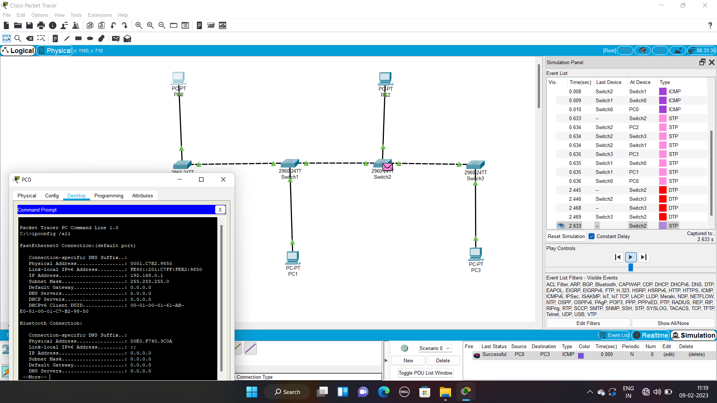

4. Design and Configuration of RING Topologies using Packet Tracer

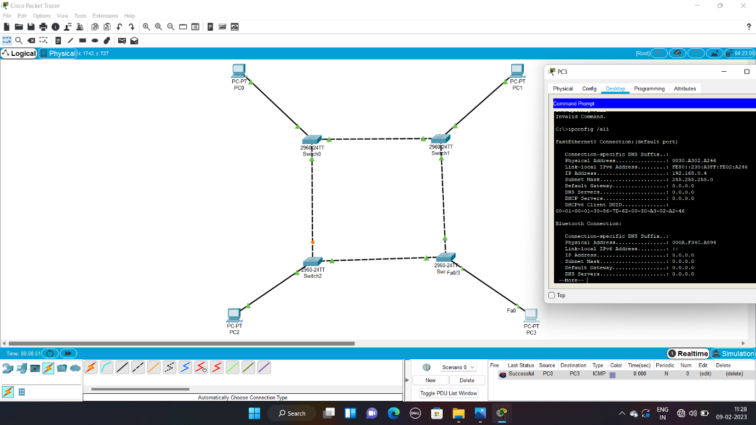

5. Design and Configuration of Mesh Topologies using Packet Tracer

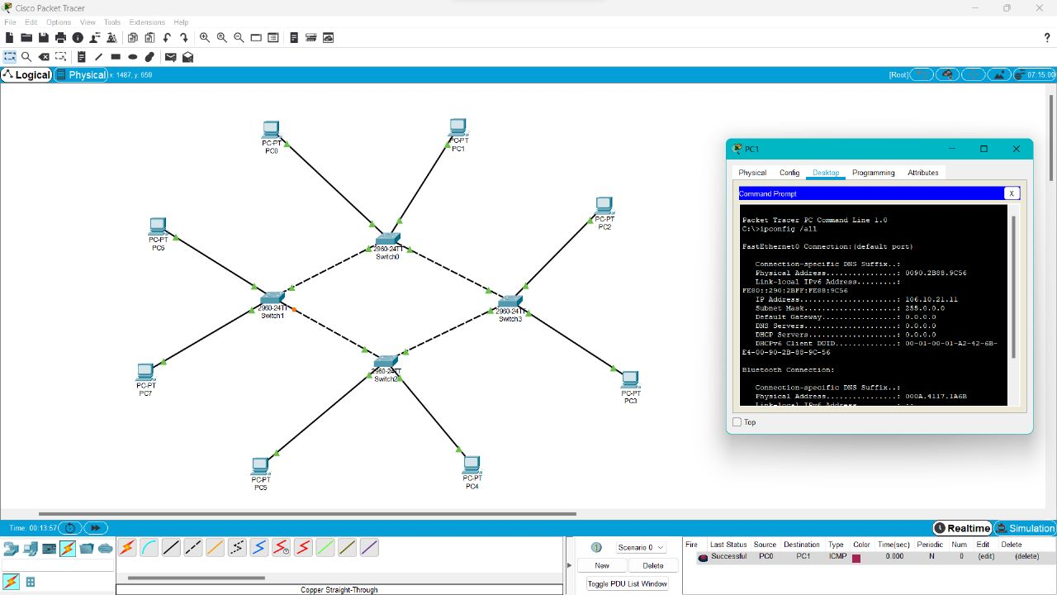

6. Design and Configuration of Tree Topologies using Packet Tracer

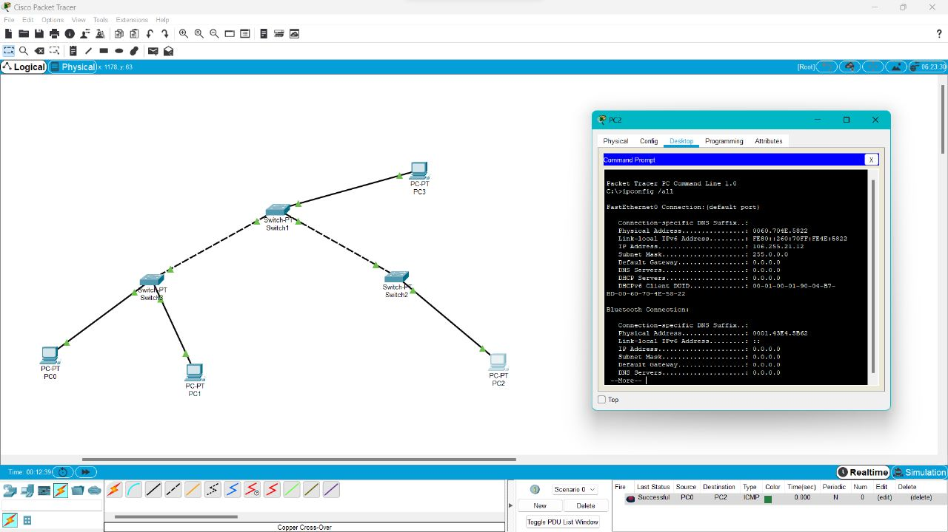

7. Design and Configuration of Hybrid Topologies using Packet Tracer

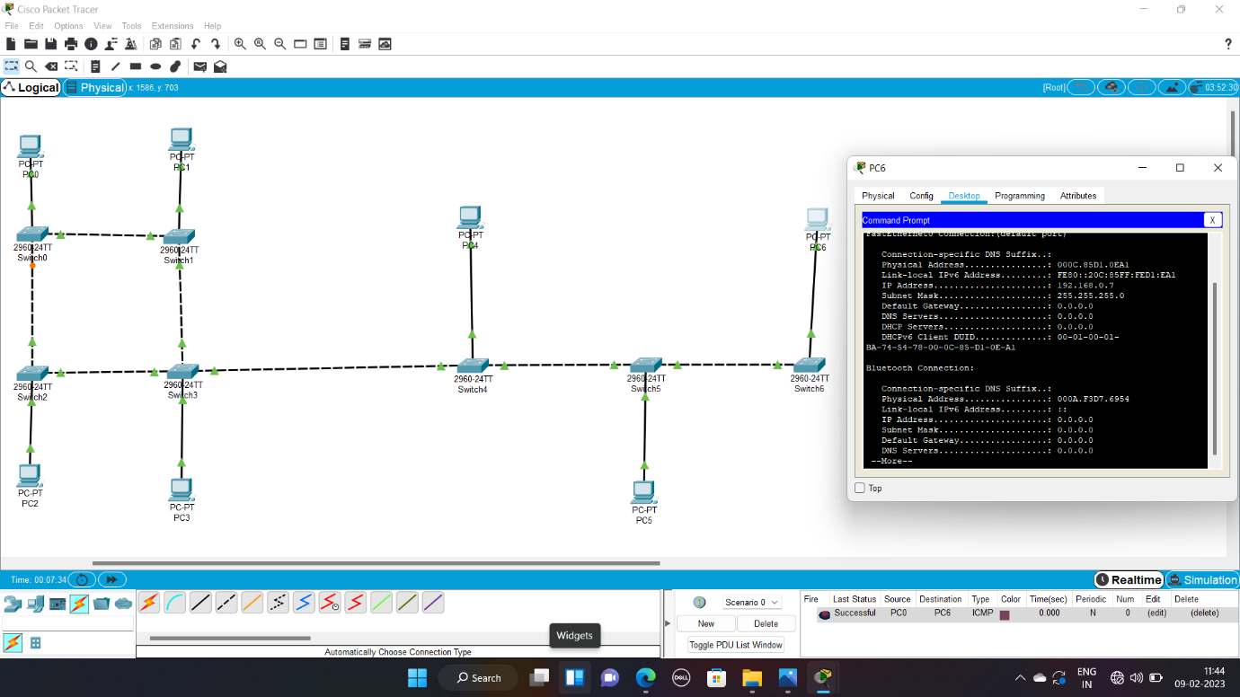

8. Data Link Layer Traffic Simulation using Packet Tracer Analysis of ARP

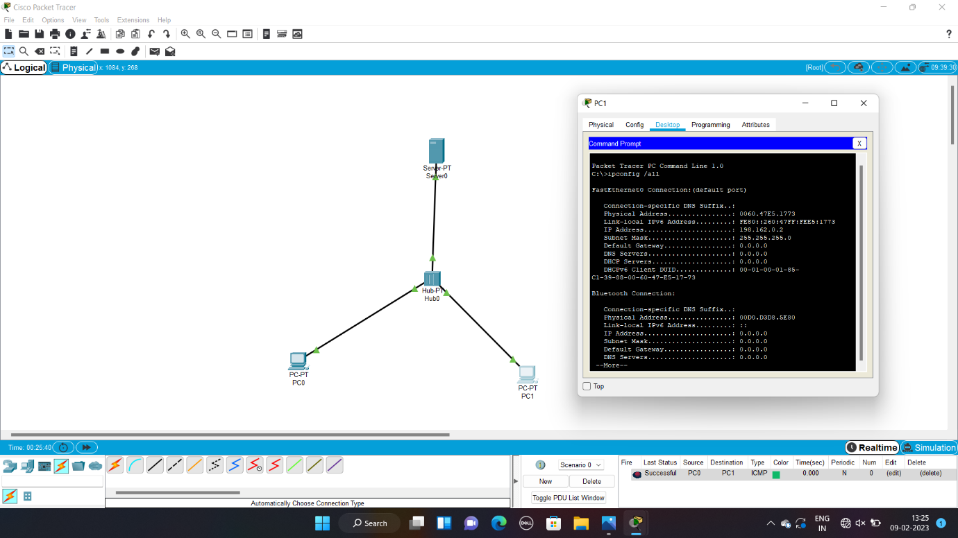

9. Data Link Layer Traffic Simulation using Packet Tracer Analysis of LLDP

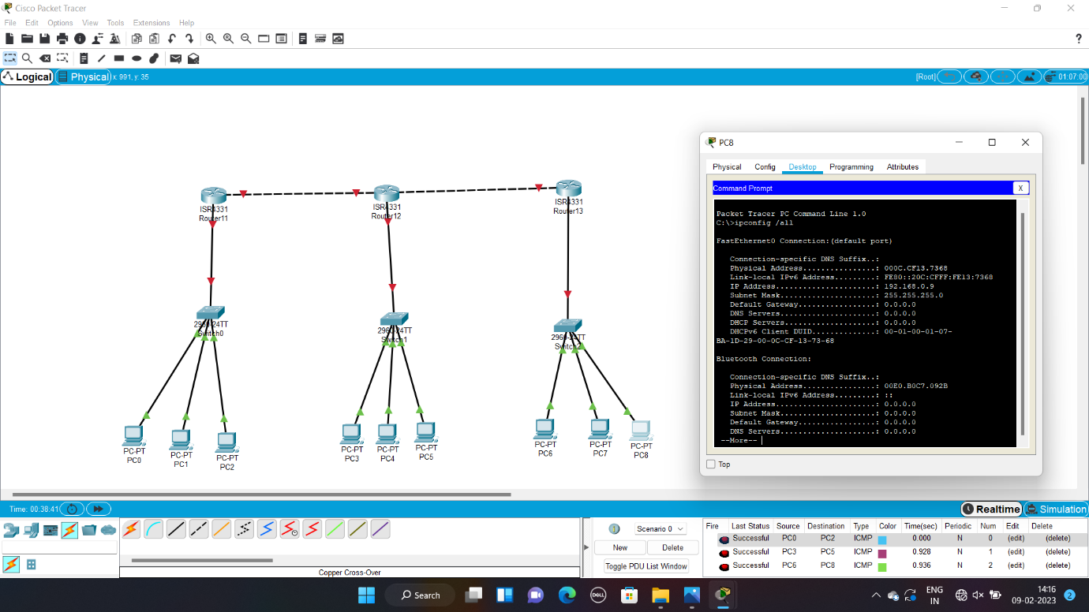

10. Data Link Layer Traffic Simulation using Packet Tracer Analysis of CSMA/CD & CSMA/CA

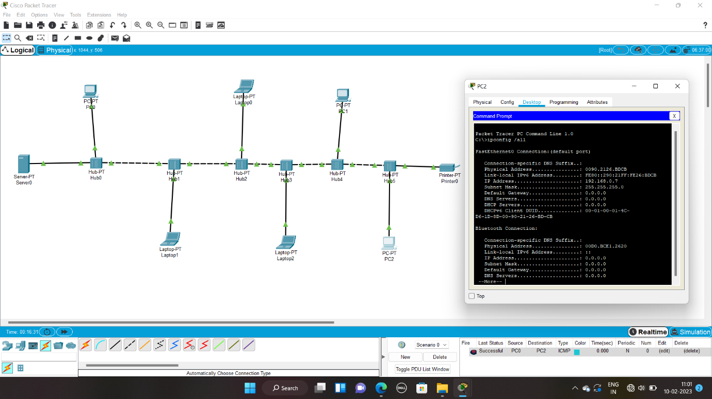

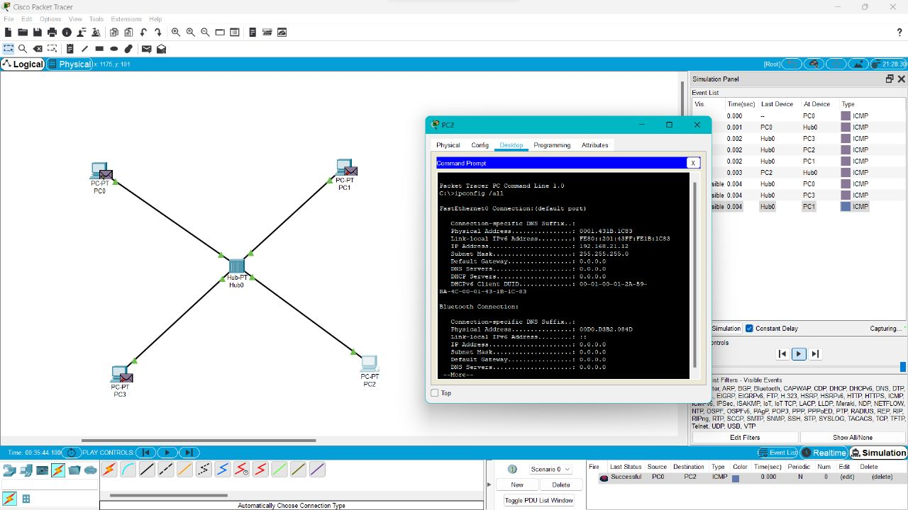

11. Implementation of Bit stuffing mechanism using C

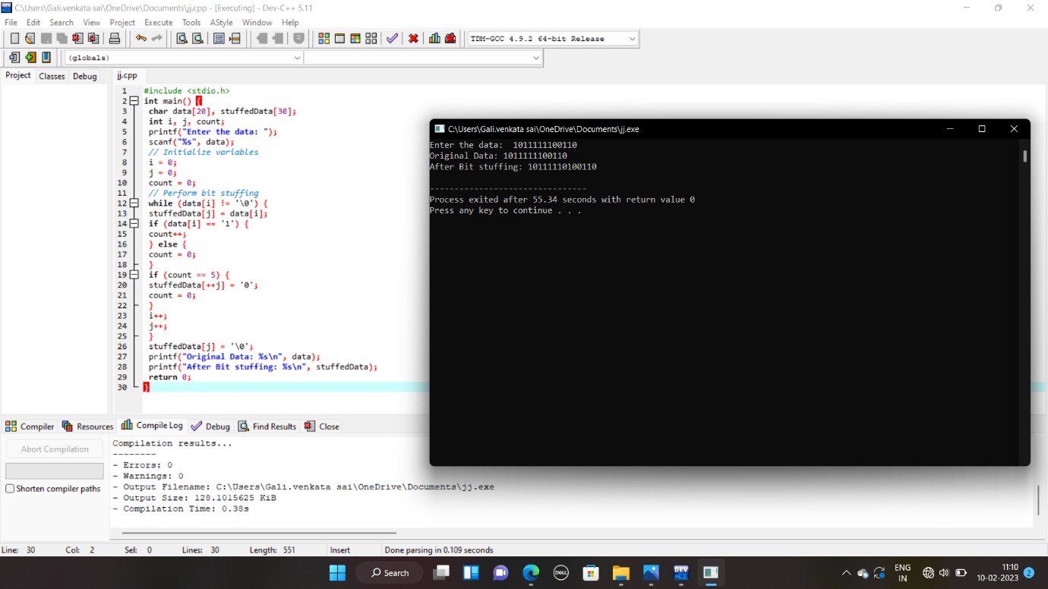

12. To design the two different network with Static Routing techniques using Packet Tracer

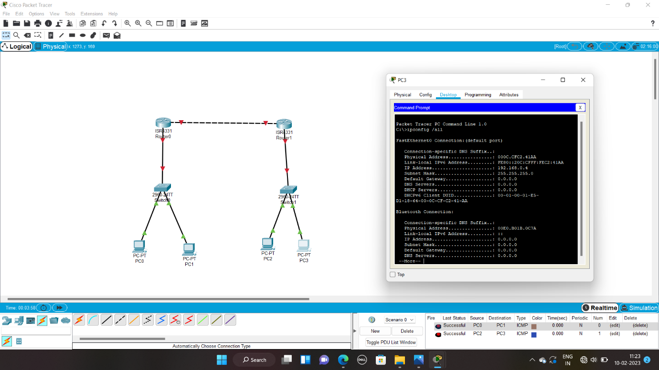

13. To design the Network with Dynamic Routing using Packet Tracer (Distance vector & OSPF)

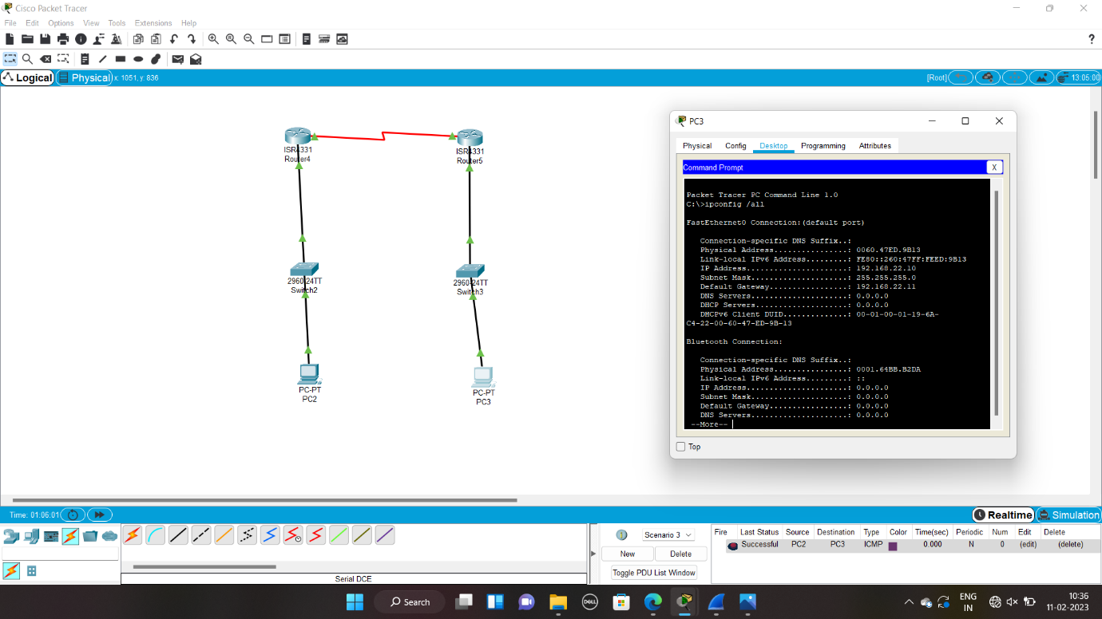

14. Design the Functionalities and Exploration of TCP using Packet Tracer

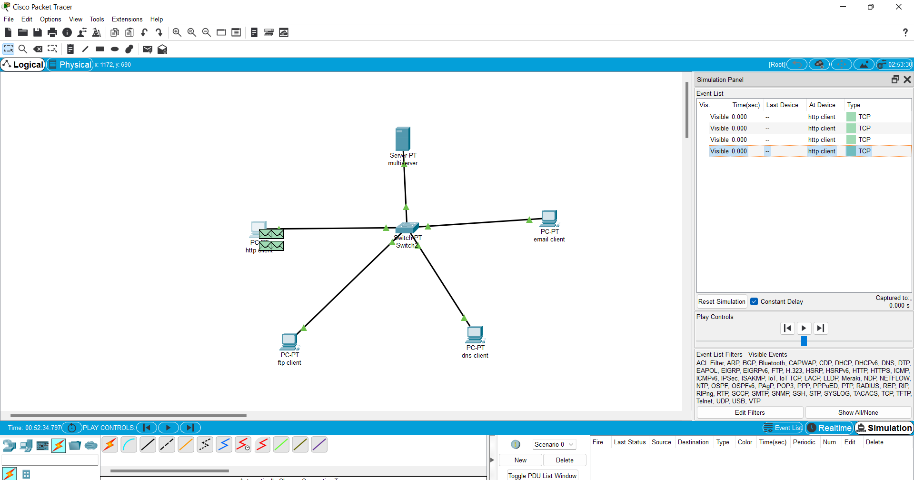

15. Design the Functionalities of Exploration UDP using Packet Tracer



16. Design the network model for Subnetting – Class C Addressing using packet tracer

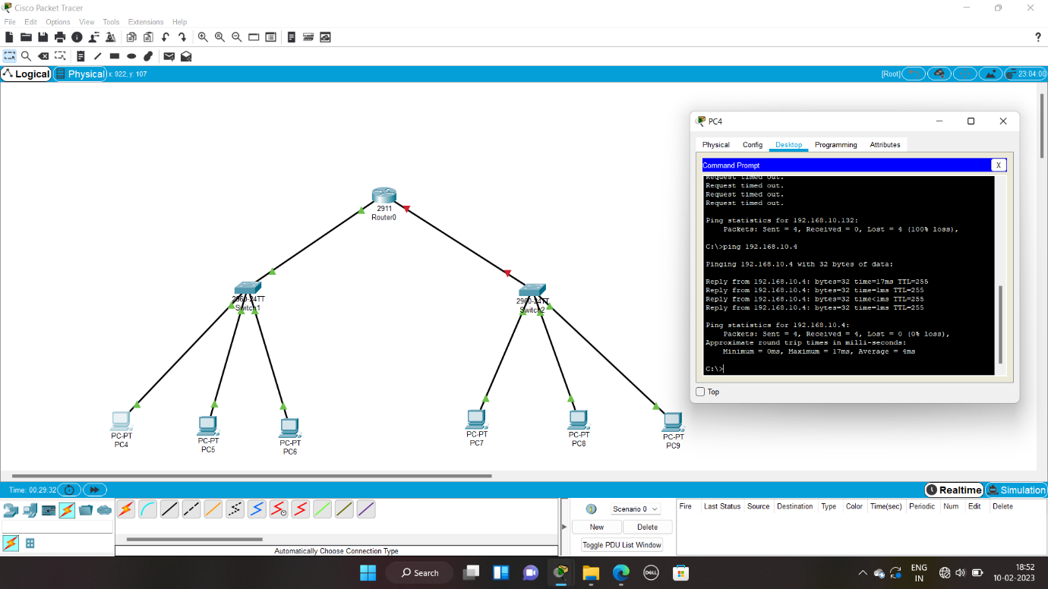

17. Implementation of server – client using TCP socket programming



18. Implementation of server – client using UDP socket programming



19. Simulating X, Y, Z Company Network Design and simulate using Packet Tracer

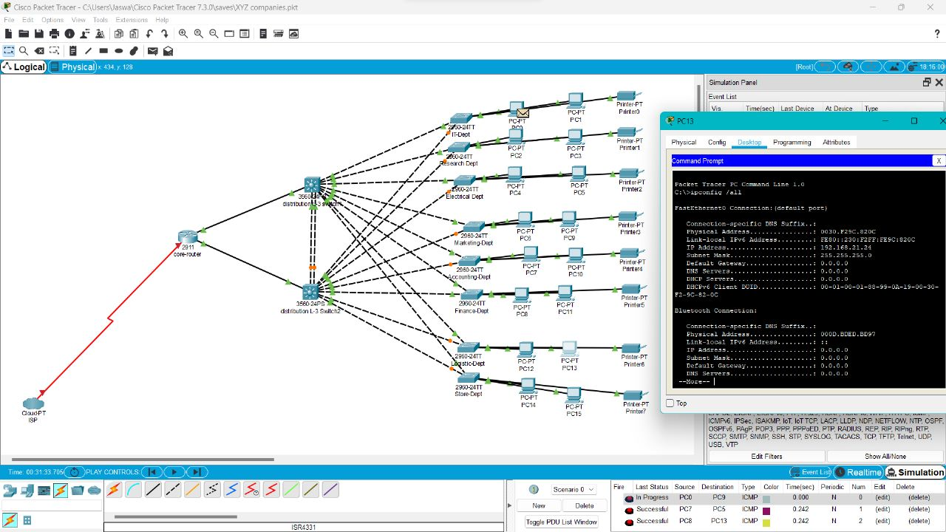

20. Configuration of DHCP (dynamic host configuration protocol) in packet tracer

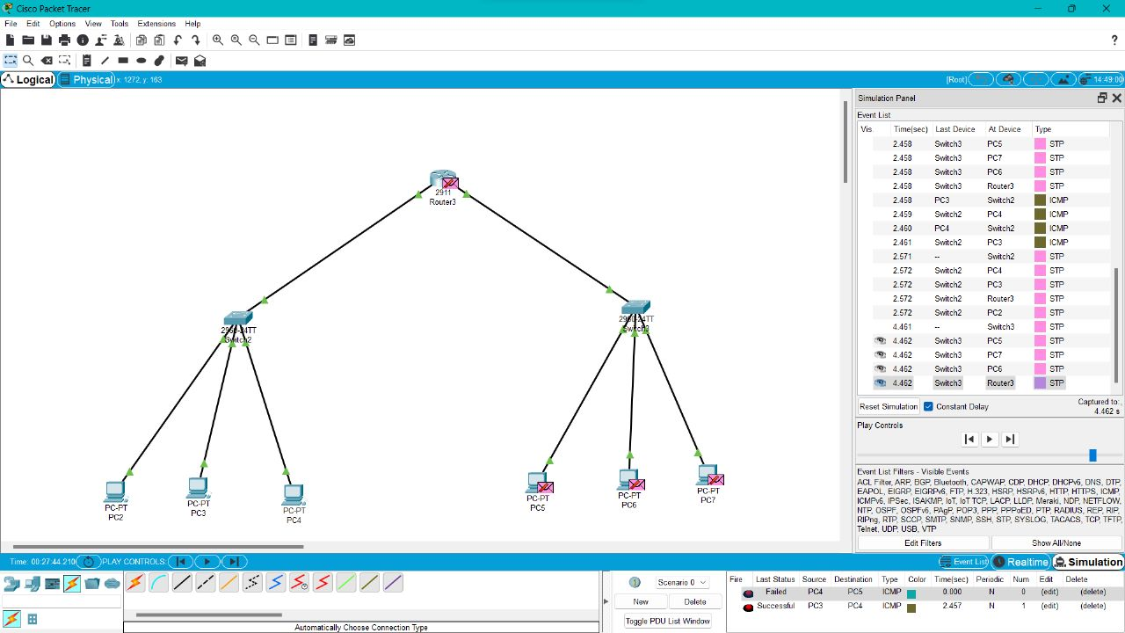

21.Make a Computer Lab to transfer a message from one node to another to design and simulate using Cisco Packet Tracer

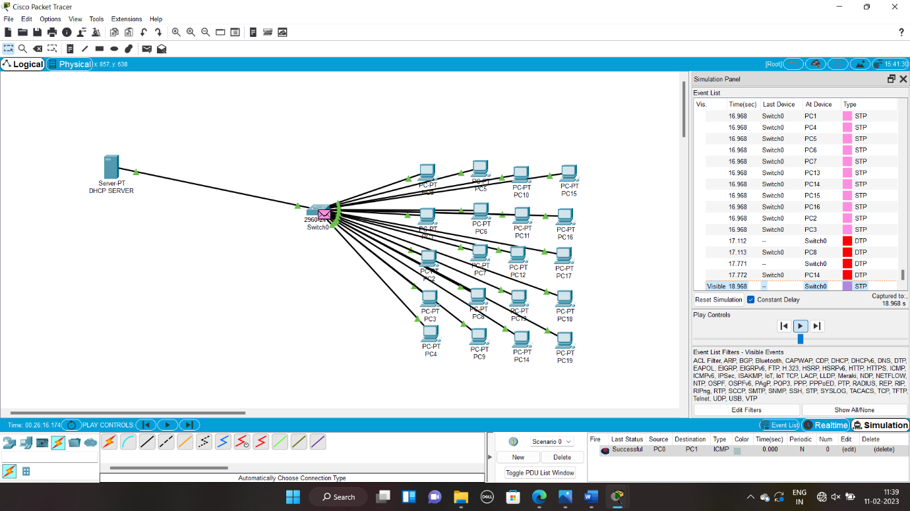

22. Transport layer protocol header analysis using Wireshark- TCP

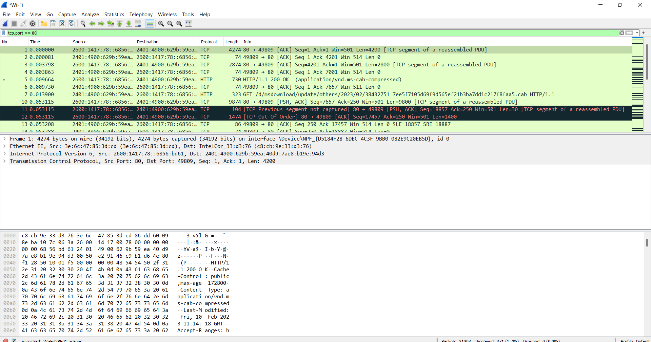

23. Network layer protocol header analysis using Wireshark – SMTP

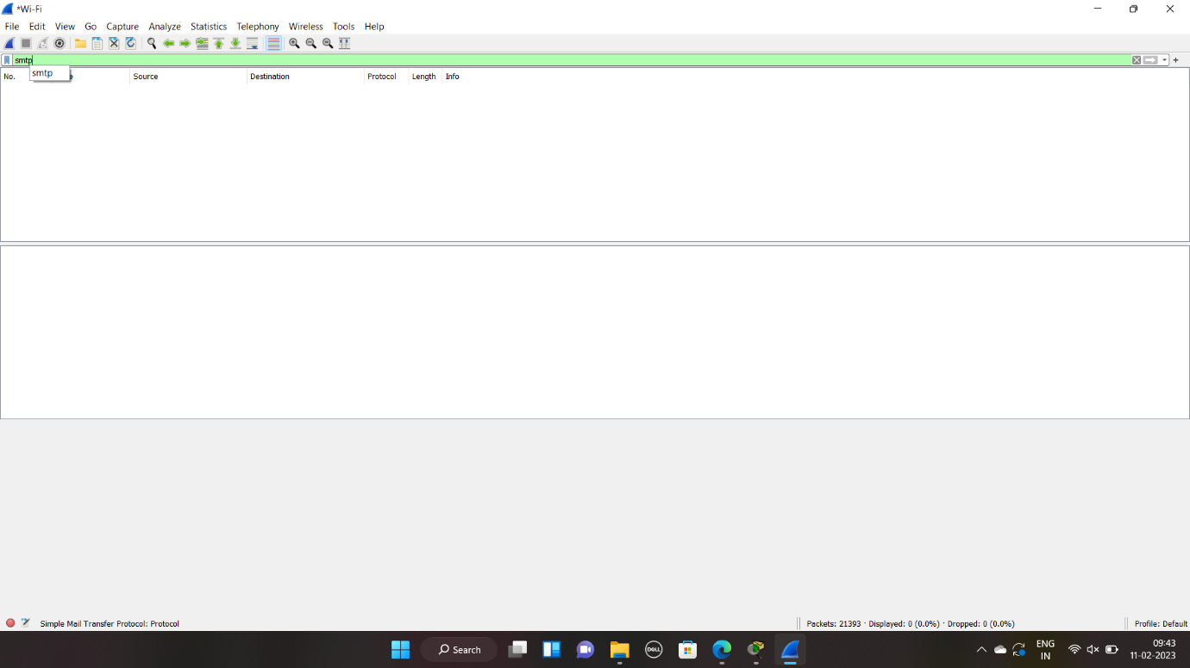

24. Network layer protocol header analysis using Wireshark – ICMP

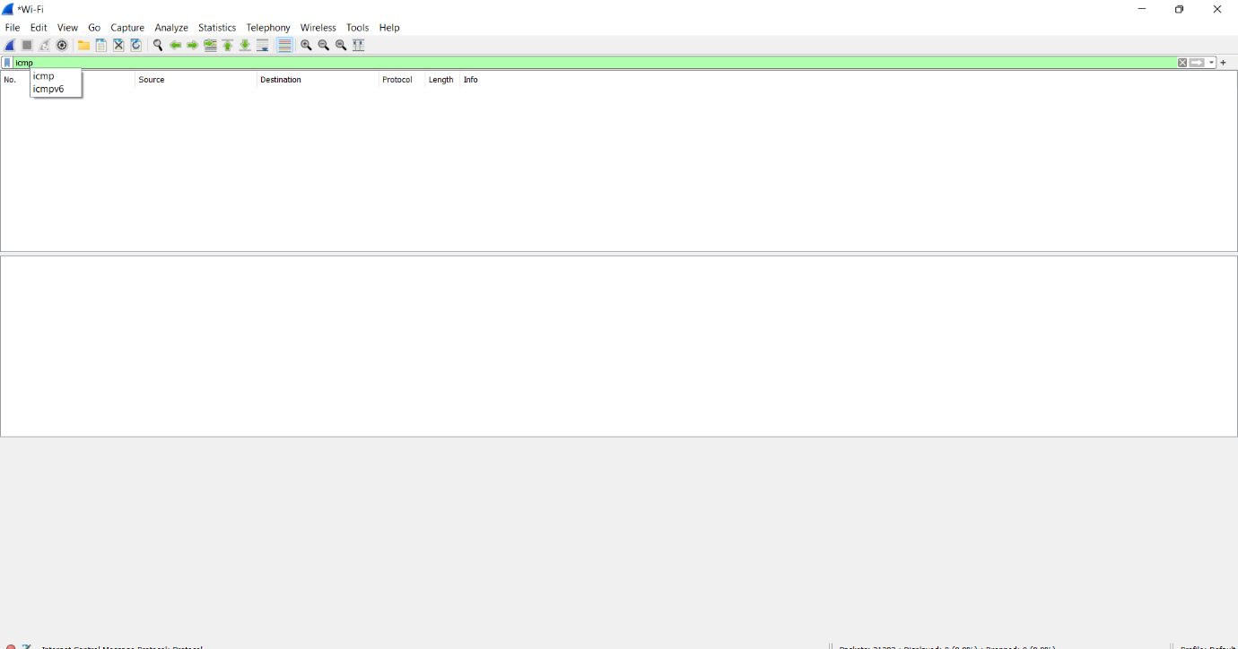

25. Transport layer protocol header analysis using Wireshark – UDP

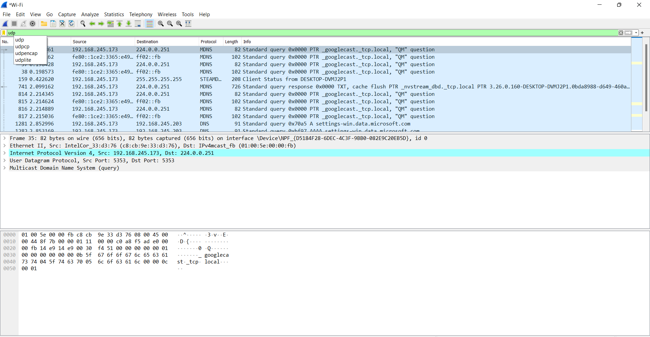

26. Network layer protocol header analysis using Wireshark – ARP

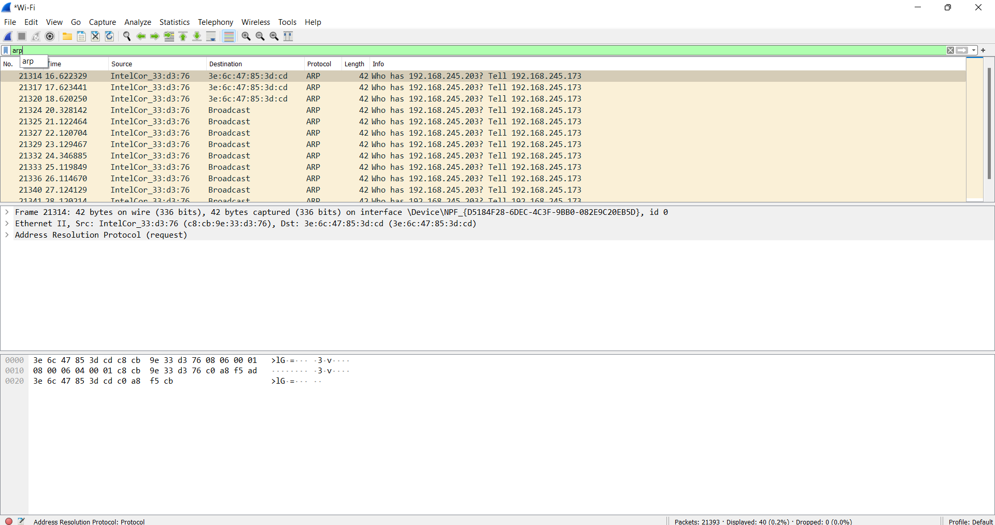

27. Network layer protocol header analysis using Wireshark – HTTP

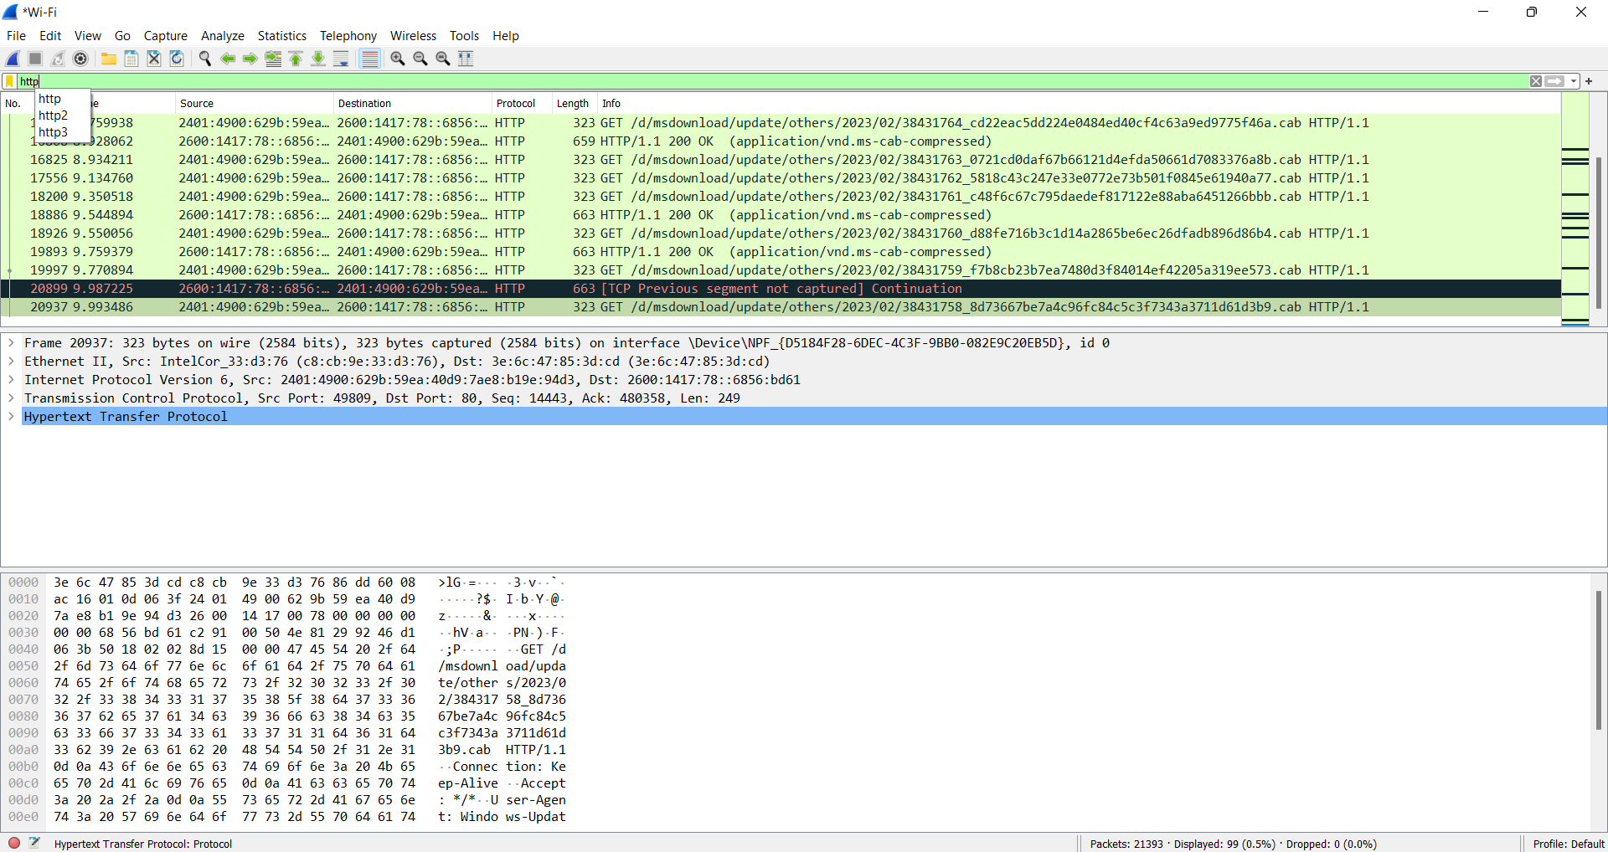

28. Demonstration of PING operation using ICMP in Wireshark

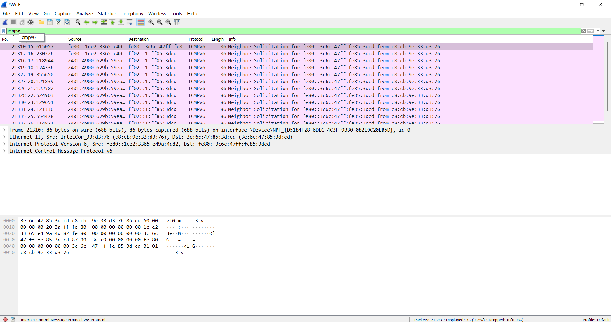

29. IOT Based Smart Home Using Cisco Packet Tracer

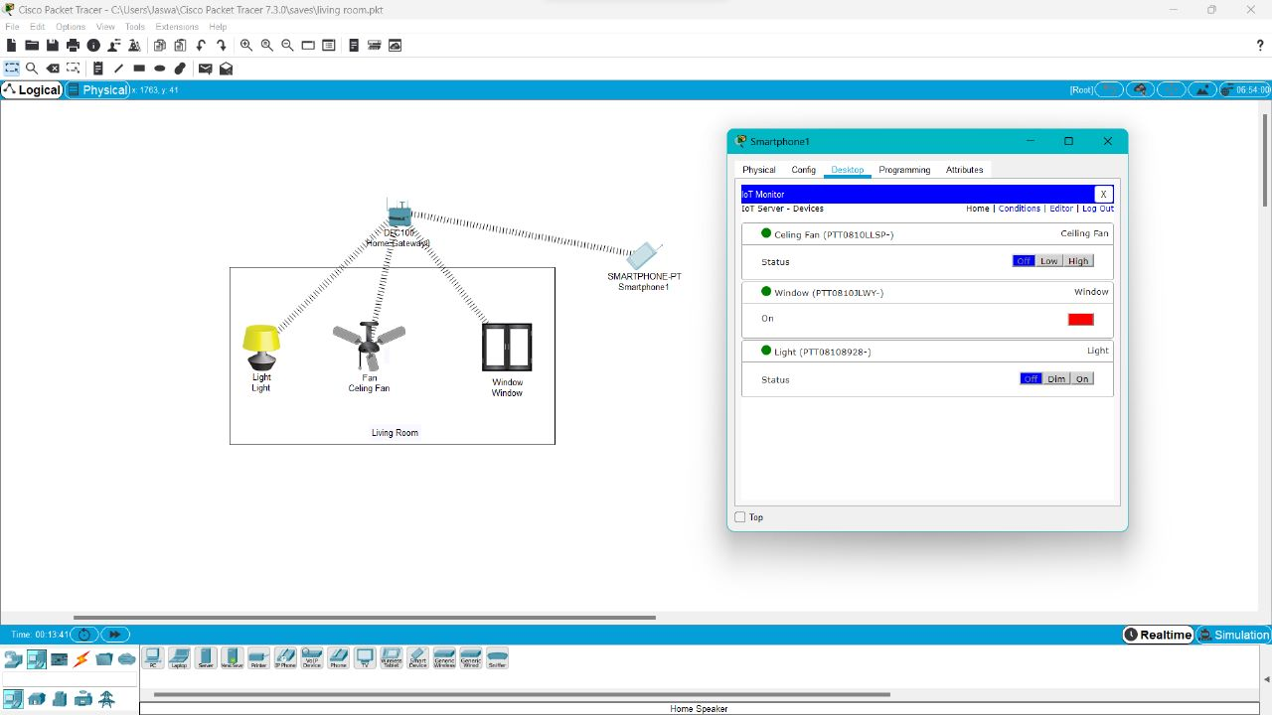

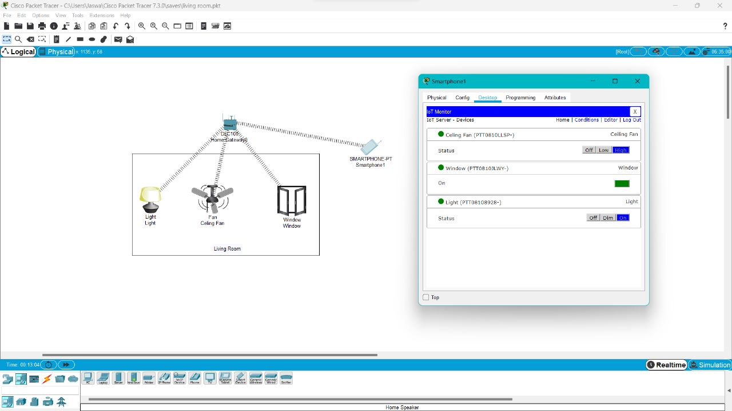

30. Smart Garden in Cisco Packet Tracer

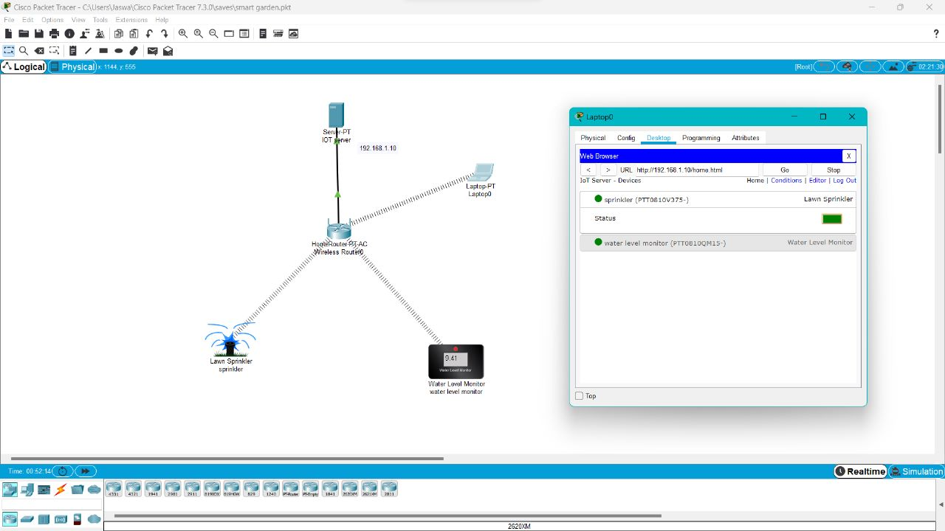

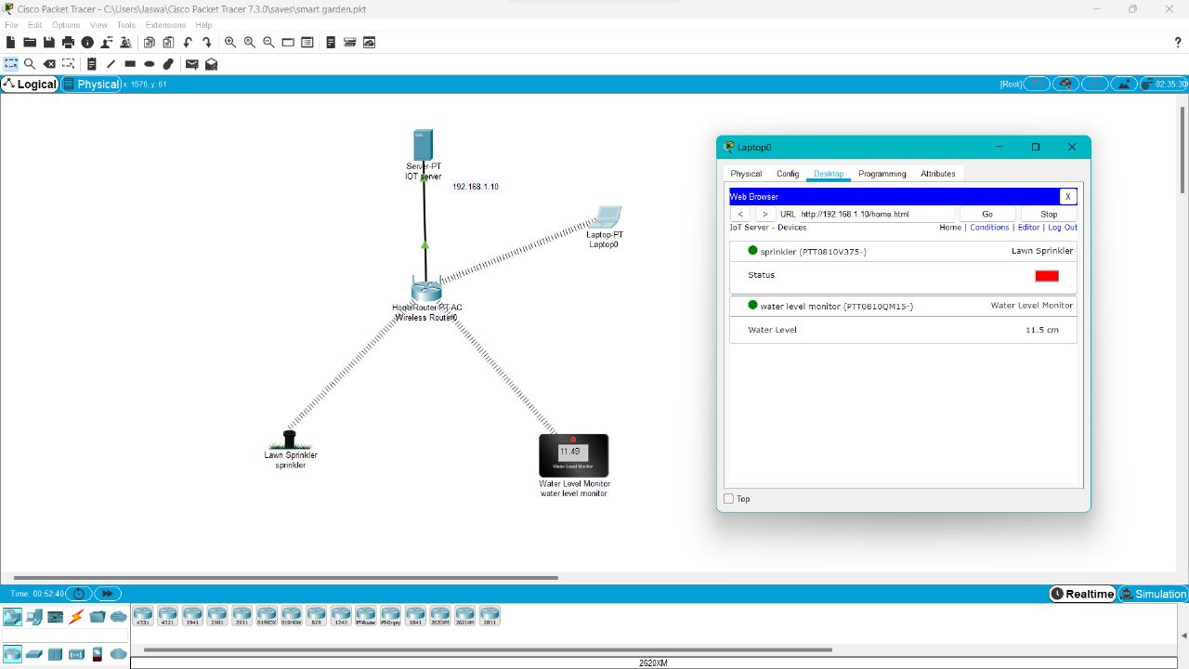

31. IOT Devices in Networking Using Cisco Packet Tracer

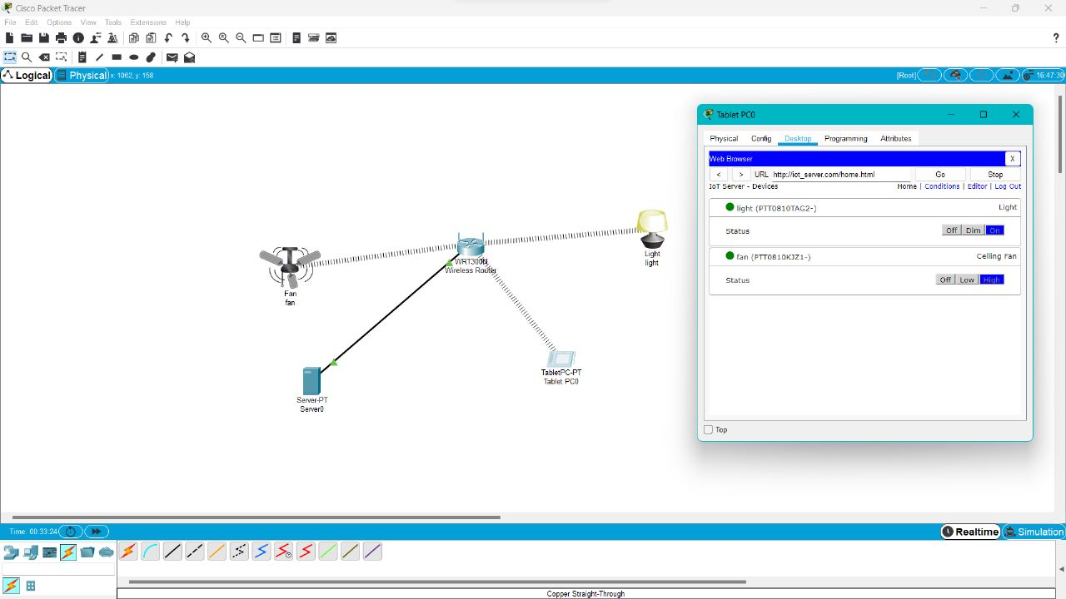

32. Control of Fan, Light, Window & Application of Using Cisco Packet Tracer

